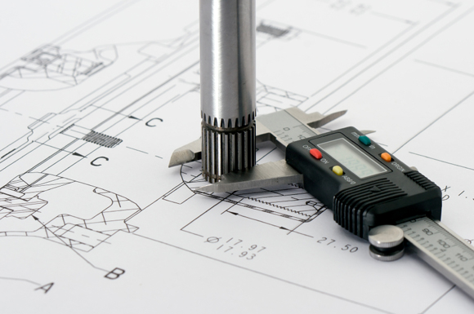

Quality & Metrology Part-Assembly Project

Coventry University Manufacturing Engineering: 156MAM

Jack Farmer (7901797), Omar Mashaly (7604717)

Word Count (body text excluding references and appendix): 5027 words

Table of Contents

Table of Figures 2

1.0 Introduction 4

2.0 ‘Gurus’ and Key Themes of Quality 4

2.1 Philip Crosby 4

2.2 W. Edwards Deming 4

2.3 Key Themes of Quality 5

3.0 Current State Analysis 5

3.1 Scrap Rate Analysis 5

3.2 FMEA Analysis 8

3.3 Control Plan Analysis 9

3.4 Process Flow Layout Analysis 10

3.5 Piece Part Costing & Cost of Quality Before Improvements 11

4.0 Review of Current Quality & Metrology Equipment and Techniques 12

4.1 Bending Operation (OP10) 12

4.2 Endform Process (OP50) 13

5.0 Future State Proposal 14

5.1 Proposed FMEA 14

5.2 Proposed Control Plan 16

5.3 Alternative Methods for Quality Inspection 16

5.3.1 Bending Process (OP10) 16

5.3.2 Endform Process (OP50) 17

5.4 Piece Part Costing & Cost of Quality After Improvements 18

6.0 References 19

7.0 Appendix 20

7.1 Appendix 1: Work Breakdown Structures 20

7.2 Appendix 2: Data Collection Spreadsheet 21

7.3 Appendix 3: Current FMEA 22

7.4 Appendix 4: Current Control Plan 24

7.5 Appendix 5: Bill of Materials 25

7.6 Appendix 6: Jig Calibration Documents 26

7.7 Appendix 7: Proposed FMEA 28

7.8 Appendix 8: Proposed Control Plan 30

# **Table of Figures**

Fig 3.1-1 Pareto Chart based on provided scrap data Page 5

Fig 3.1-2 Definitions of Pareto codes Page 6

Fig 3.1-3 Spreadsheet of Level 3 data collection Page 7

Fig 3.1-4 Summary of data collection findings Page 7

Fig 3.1-5 Dimple on pipe (location 2) Page 8

Fig 3.2-1 Current FMEA sample Page 8

Fig 3.4-1 Current process layout Page 11

Fig 4.1-1 Photo of current bending gauge Page 13

Fig 4.2-1 Endform test on current bending gauge Page 14

Fig 5.1-1 Proposed FMEA sample Page 14

Fig 5.1-2 Example of SPC chart Page 15

Fig 5.3.1-1 Image of a Dial Test Indicator Page 16

Fig 5.3.1-2 Proposed DTI locations Page 17

Fig 5.3.2-1 Image of proposed CMM Page 18

**Key**

This group report has been written by two people. It is colour coded to show which person has written each part. The key is as follows:

Jack Farmer (7901797)

Omar Mashaly (7604717)

# **Introduction**

The aim of this project is to analyse the current manufacturing system and metrology plans in place at Unipart Powertrain Applications, in the fuel filler bending area. This analysis is then to be used as a basis for identifying opportunities for improvements to quality checks and inspections; with the aim of reducing costs due to scrap and over processing. This ultimately reduces unnecessary costs for both Unipart and their customers, in this case Jaguar Land Rover.

# **‘Gurus’ and Key Themes of Quality**

## **Philip Crosby**

Philip Crosby was an American Quality Engineer and later a Director of Quality, most known for his best-selling 1979 book “Quality is Free”. Crosby, unlike some other quality gurus focused on prevention of defects, rather than cure or inspection. He believed that quality should focus on assuring success, rather than measuring rates of failure. (British Library, 2018)

In his book, he laid out his fourteen steps to quality. This included quality measurement which could perhaps be considered the most important. Crosby suggested that quality should be measured throughout a company and process by establishing measures for each area. He felt it was important that measurements are taken by operators working on the factory floor, as they are most familiar with the parts and processes used. (British Library, 2018)

This is performed to an extent at Unipart currently. Operators perform jig tests and visual inspections on parts in the fuel filler assembly area. However quality checks are currently not set up at each stage; rather the filler is tested on a jig after all bending and end forming processes have taken place. Crosby’s ideas and contributions should be considered when producing improved FMEAs and Control Plans.

## **W. Edwards Deming**

W. Edwards Deming was a statistician and business consultant credited with developing the concept of Total Quality Management. Much of his work is based upon the findings of Walter Shewhart, who experimented with applying statistical techniques to manufacturing processes. One example is the PDCA Cycle; which stands for Plan, Do, Check and Act. This is a repeating cycle used to solve problems, hence enabling continual improvement. (British Library, 2018)

## **Key Themes of Quality**

In order to have a good quality check for everything included in the report, there must some themes that are used for each part to check if it is done right or wrong, and does it need to be changed or modified or is it good enough to stay the same. Some of these themes are:

* To visually check the things done twice, because when visually checking things by another person, there might be some errors that the first person did not notice while doing things.
* Beside visually checking, some things need to be studied by timing them. So that it is known if it is done in a correct way in an acceptable time.
* And sometime calculations must be done in order to achieve the best result for the thing in hand needed.

These points are related to the steps of some quality gurus such as Joseph M Juran. To check anything that needs improvement, there will be visual checks, timings, calculations, etc. that helps identify the problems. So the gurus came up with steps and methods to improve the quality of everything such as the 10 improvement steps that Joseph M Juran made.

# **Current State Analysis**

## **Scrap Rate Analysis**

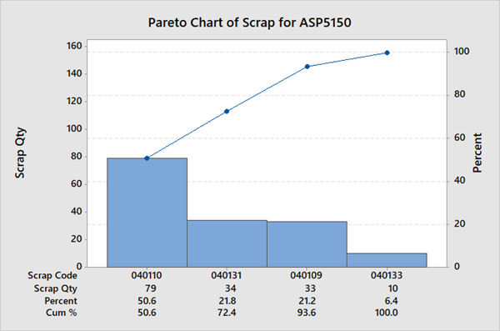

Figure 3.1-1 Pareto graph based upon provided scrap data

A spreadsheet was provided from Unipart containing details on the occurrence of scrap. It contains the time and date of the scrap occurring, the ‘scrap code’ which refers to the reason for the scrap, as well as the quantity of scrap and how many times it has occurred. The spreadsheet covered a timeframe of 03/07/2017 to 18/01/2018; approximately a 7-month period of time.

A Pareto chart was created from the provided scrap data (See figure 3.1-1). Pareto charts were developed by engineer Vilfredo Pareto. It contains both a bar and line chart on the same axis, where the line represents the cumulative percentage whilst the bars represent the occurrence of each scrap type. This means different scrap causes, for example, can be easily compared against each other visually.

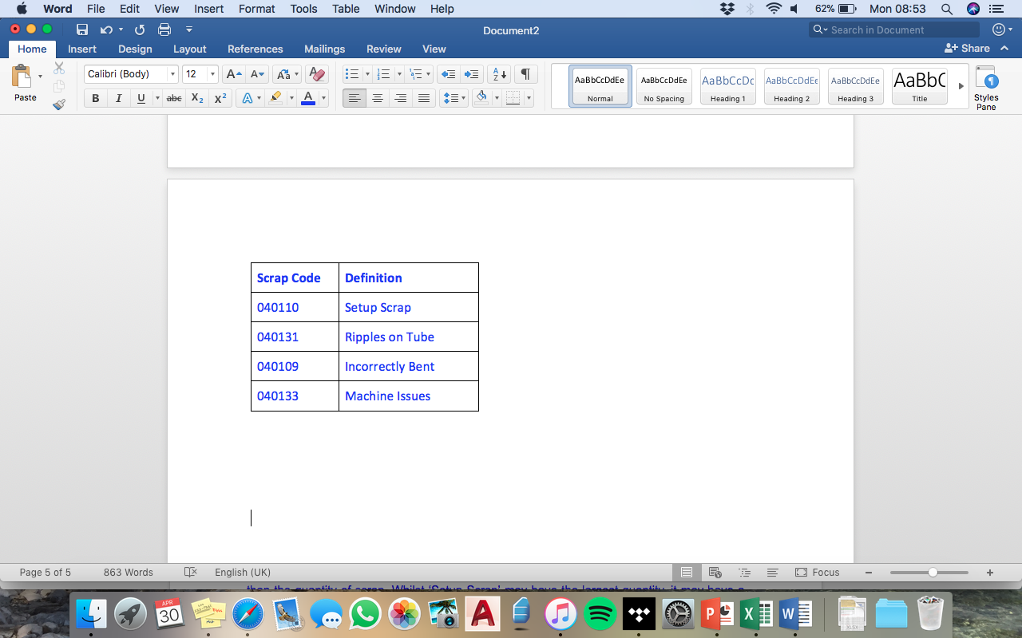

Figure 3.1-2 Definitions for Pareto scrap codes

A table shows the scrap codes and their definitions (see figure 3.1-2). It can be seen that the scrap data does not conform to Pareto’s 80/20 rule. The rule suggests that 80% of scrap quantity is caused by 20% of scrap codes; however, it can be seen that this is not the case and in fact 80% of scrap quantity is caused by around half of the scrap codes. This means that when looking at areas to improve upon to reduce scrap, a wider range of improvements are needed to reduce scrap as it is caused across many different areas.

An alternative way to analyse scrap using a Pareto chart is to look at the cost of scrap rather than the quantity of scrap. Whilst ‘Setup Scrap’ may have the largest quantity, it may have a smaller cost than other types of scrap, for example. The aim of reducing scrap is to reduce cost, so this is a better indicator of which scrap causing processes should be targeted most when making improvements.

As for the scrap of the endform which are done incorrectly, the scrap per year was 10 given the code of ‘40116’, and as described before there are other scraps in the pareto chart.

Usually the error for the endform comes from an error in cutting, where when they cut the ending of the bent pipe sometimes it makes the surface unequal with edges in it that can and can’t be seen by the naked eye, so when it goes to the endform machine, it doesn’t make the right shape needed due to that the surface after cutting is not the surface needed to acquire the shape that needs to be done. So there must be a way to reduce the errors while cutting the pipe.

One issue is that the Unipart scrap codes are not necessarily descriptive, as ‘Machine Issues’ for example does not specify the machine that was causing the problem, or the issue itself. Hence it was necessary to collect new data to further analyse the situation.

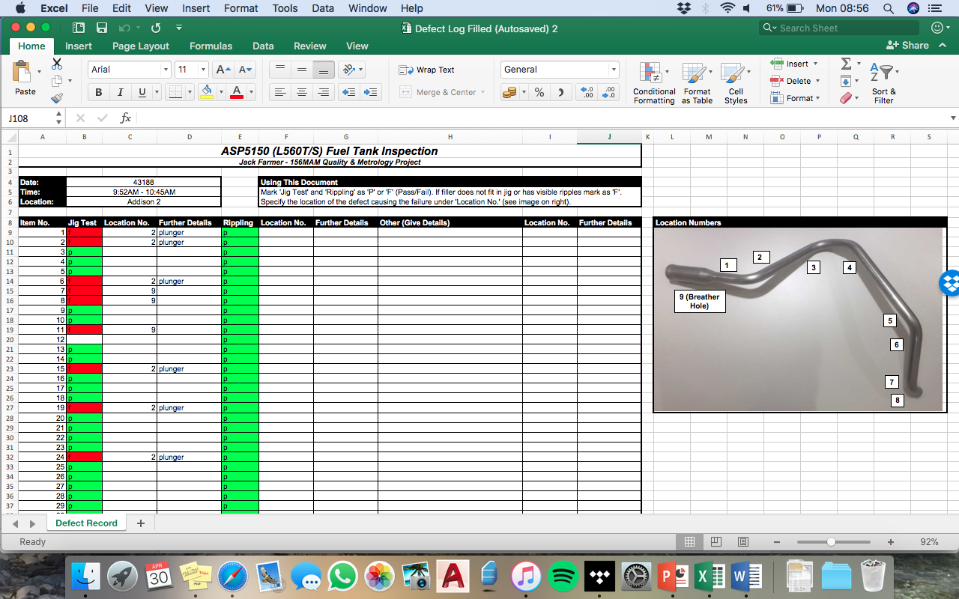

Figure 3.1-3 Spreadsheet developed for level 3 scrap data collection

A spreadsheet (see figure 3.1-3) was created which was used in conjunction with the existing jig to check parts. Points on the pipe before and after each bend were numbered allowing the data collected to be location specific. This meant that scrap causes could be narrowed down to certain bends, making it simpler to find the causes of bending faults. A column for rippling was also added, where a visual check was performed as it was identified in the Unipart data to be a problem.

A full version of the spreadsheet with all data entries can be viewed in the appendices (appendix 2).

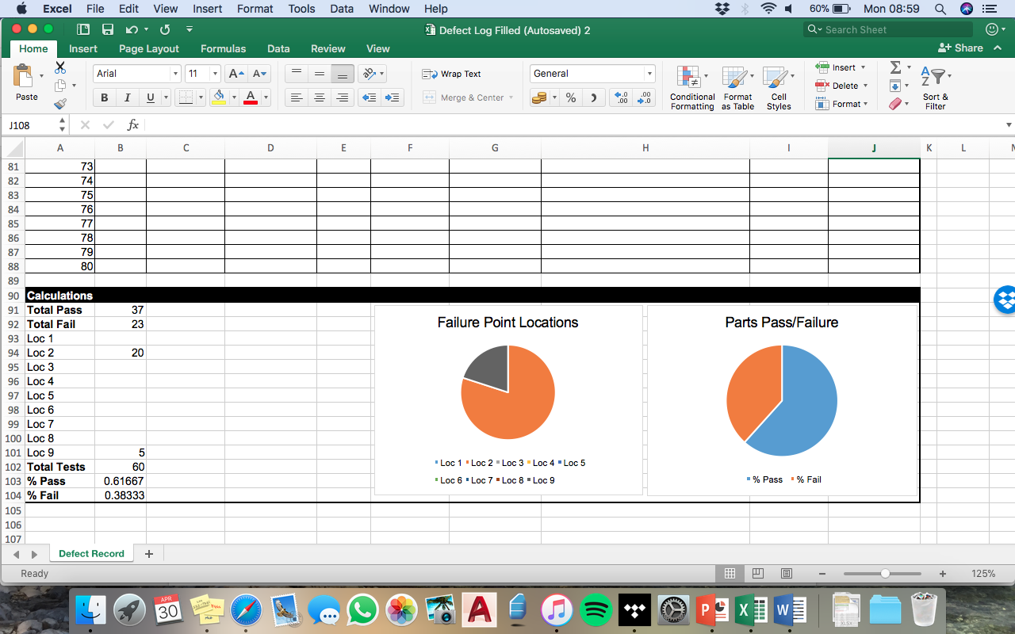

Figure 3.1-4 Summary of data collected from filler inspection

From the data collected over the course of one batch of filler pipes, it was found that only 61.7% of pipes fit in the jig and hence were in tolerance for all dimensions. This is surprising considering supposedly all of the pipes had passed the existing quality check and were ready to be sent to the customer.

As shown in figure 3.1-4, all instances of scrap were caused by locations 2 and 9, and in two occurrences both areas simultaneously. Location 2 is after the first bend, where a dimple appears below the bend (see figure 3.1-5). In theory, this does not affect functionality as pipe is still water tight; but in reality, no longer fits in jig as the area surrounding the dimple is wider. It should be kept in mind that the fuel filler must fit in a small channel inside the car and hence must fit inside the jig. The dimple at location 2 is likely caused by insufficient support inside the pipe whilst bending, where the support is either too small in diameter to support the inside wall of the pipe or is not long enough to support the whole area surrounding the bend.

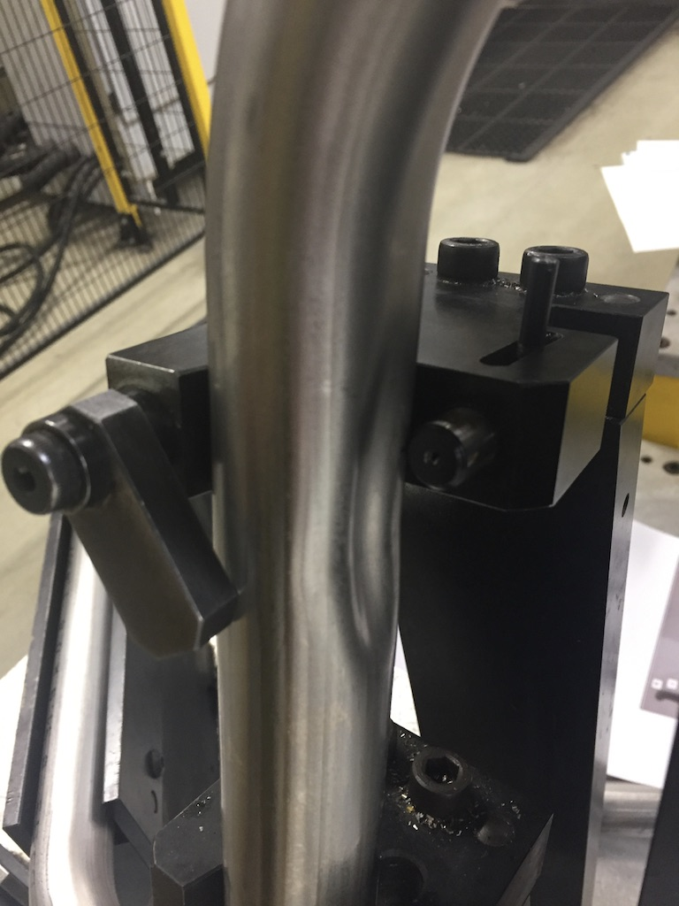

Figure 3.1-5 Dimple at location 2 of filler

Location 9 is the breather hole on the end cup. It was misaligned from the plunger on the jig by a few millimetres at most. This could be the result of the bend starting slightly out of place, due to the aligning notch not fitting correctly. Alternatively, the breather hole may be out of place on the end cup, caused in a previous process when the end cup was formed.

## **FMEA Analysis**

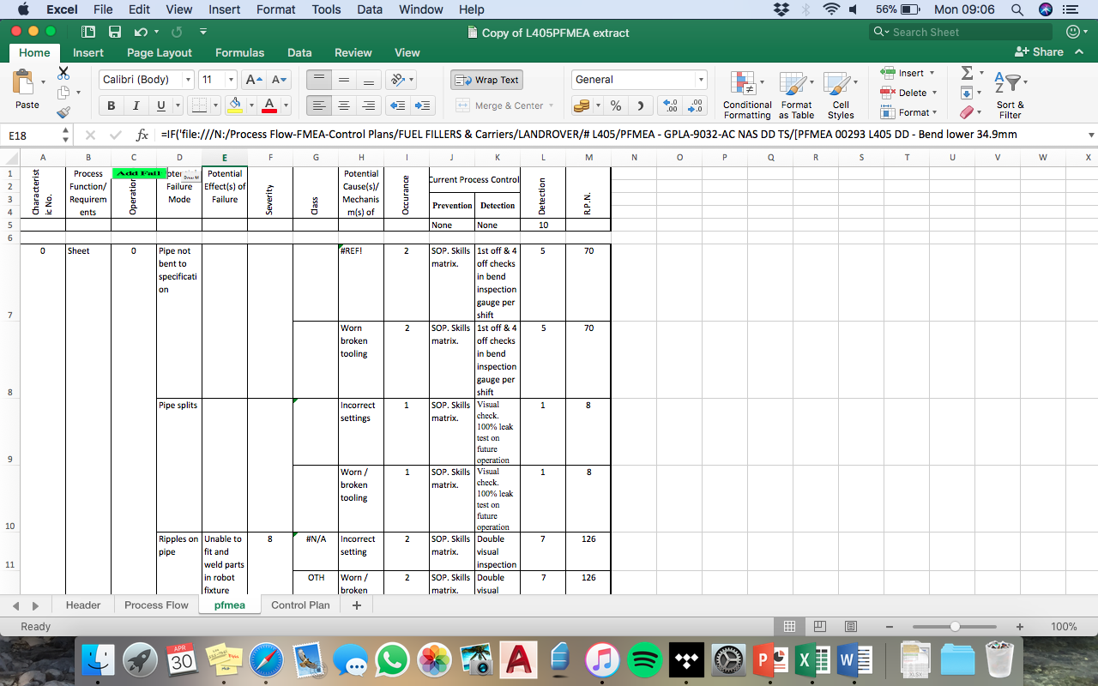

Figure 3.2-1 Sample of current Unipart FMEA

The current Unipart FMEA (see figure 3.2-1) is inadequate for the task at present. Crucial data is missing, primarily the process function and requirements; and other data is either lacking in information or is inaccurate (for example the RPN calculations are almost entirely mathematically incorrect).

The “Process Function/Requirements” column should briefly outline the process however this is far too brief and would be difficult to understand for employees less familiar with the processes.

For some rows, the “Potential Effects of Failure” column is either missing or lacking in key detail. This column is very important as it outlines to the Unipart team member the likely outcomes of a part/process failure. This gives team members an idea of what to look out for when inspecting parts. This column will need to be re-written to give greater detail on the outcome of failure.

The severity, occurrence and detection (SOD) are used to calculate the Risk Priority Number (RPN), which is used to identify the failure mode which poses the greatest risk to the quality of the product. At present, the SOD numbers have no key which limits their effectiveness. Hence, a ‘5’ rating for severity, for example, is effectively meaningless without a key.

Hence, an accurate key must be implemented to make the SOD numbers, and hence the RPN, useful.

However, a more concerning problem is that the RPN numbers, which are calculated by multiplying the severity, occurrence and detection numbers, are almost all mathematically incorrect. For example, a potential failure with an S rating of 9, O rating of 3, and D rating of 7. The S and D ratings would suggest there is a relatively serious problem. However, the RPN number, which in theory should be 252, is recorded as zero. This means that despite the very high rating, Unipart would seem to suggest there is no problem. This is concerning as it means serious issues may be completely overlooked.

Hence it is necessary to revise the entire FMEA document. An entirely new FMEA document with a clearer layout should be implemented. This will include a key detailing what each of the SOD ratings means; and will have high RPN numbers highlighted to emphasise their priority.

A full copy of the current Unipart FMEA can be viewed in appendix 3.

## **Control Plan Analysis**

The control plan is a method that is used in manufacturing engineering to ensure that the products made are meeting the quality needed. It is a document that is meant to control the quality of the products in order for them to be efficient and usable for customers and meeting the requirements that the customers want.

This control plan does have some problems such as some things are missing and some things are not clear. These errors were identified by visually checking the documents, as stated previously in the theme of quality. We are here to analyse it and try to identify the mistakes in order to make a better control plan document.

The points that needs to be changed or are missing are the following:

* 1st of all in many points it says that they inspect the 1st and another 4 during the shift, they should specify which 4 are they going to inspect, in my opinion they should divide it to be equally for example if they make 100 fuel fillers per shift then the 1st will be inspected then every 25 there will be an inspection so it is divided equally and that should be specified.
* In operation 10, last 2 steps, it says there will be double visual inspection. They have to specify who will do them and when, they shouldn’t be done by the same person as he could be seeing the same thing twice while there might be another problem. It should be 2 people inspecting and they should do it after each other. That should be specified in the document.
* Anything with double visual inspection, must be corrected and specified as the previous one stated.
* There is no document on how to program the computer to bend the pipe for the exact model given. There should be a document on how to program it and how not to make mistakes so that the program will bend the right model instead of bending the wrong angles on the pipe.

## **Process Flow Layout Analysis**

The process flow layout is the layout which is how the machines are organised with the distances that is existing right now in the factory.

The layout is organised in a rectangular area which includes at the far left as seen on (figure 3.4-1) there is the bender, then right in front of it on the top 2 meters away there is the personal computer which you choose exactly the bends of each fuel filler that is programed on the computer, right beside it there is the chop saw, the De Burr is the next machine, then on the right side there is the cup form sizer, under it is the wash machine and finally there is the rack. All of this area is made in a 6.2 meters length and 4 meters width making the area 24.8 m2.

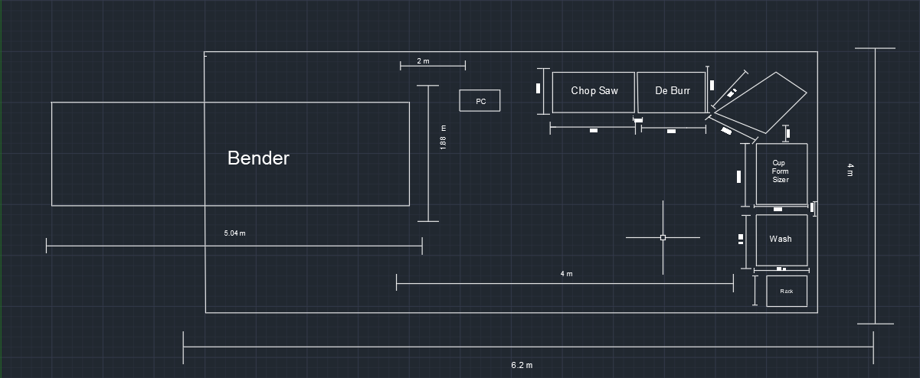

Figure 3.4-1 Current layout of the bender cell

As for how these machines are spread, the quality check for the pipe after each process is not a problem as they check everything visually during the whole process after each station in it. The only problem is that there is not enough equipment to check the quality for each station. This conclusion of the layout was determined by timing the whole process, which is 62 seconds, checked visually, and the area was calculated so that the layout was concluded to be good enough to be used and not changed. These quality themes were discussed before in the key themes of quality.

## **Piece Part Costing & Cost of Quality Before Improvements**

The piece part costing is the cost of one piece of a fuel filler after calculating everything needed. The equation of the piece part costing is the direct material plus the direct labour plus the cost of quality. The direct material and direct labour is the same as it was calculated for the whole process and the same material is used for the whole fuel filler.

The average direct material cost was £7.66. This was obtained from a Unipart document which can be viewed in appendix 5.

Then direct labour is calculated by multiplying the cycle time of the whole process by the cost of the worker per hour which was 62 seconds for 1 process, converting that into hours the time for one cycle is (17.22 x 10-3) and the cost per hour for the worker is 16.80 pounds; the direct labour would be (17.22 x 10-3) x 16.80 = £0.29 per one fuel filler done.

As for cost of quality, it was calculated by adding the results of three equations. The first was the cost of scrap, in which the equation was quantity of (scrap x (direct material + direct labour)) / good parts produced; the scrap was 10 per year for the endform, and the parts produced is about 31000 per year, the result found is £2.56x10-3.

The scrap for the bending of the pipe was 156 over the 7-month period, averaging to 267.4 annually. Hence using the equation as above, the cost of scrap per part is £0.07.

The second equation to calculate is the cost of detection, and that is to calculate the amount of quality checking which is (visual inspection x 0.29) / 31000 + (gauge check x 0.29) / 31000 + (cost of gauge) / 31000. The visual inspection takes about 3 seconds, the gauge check takes about 44 seconds, and the cost of the gauge is 3995 pounds; giving the result to be £0.1293 per part.

The third and last equation is the cost of conformance which are ((documents created time x 16.80) + (training time x 16.80)) / 31000. The time calculated for all the documents were 4.5 hours and the time for the training was also about 98 hours; giving the result to be £0.06 per part.

Adding them up gives the result of the cost of quality which is £0.26 per part. Then we add the cost of washing which is £0.14 and the cost of direct labour and direct material to the cost of quality. All of that gives us the piece part costing which is £7.66 + £0.29 + £0.13 + £0.06 = £8.14 per part.

# **Review of Current Quality & Metrology Equipment and Techniques**

## **Bending Operation (OP10)**

Currently, there are no quality checks before, during, or immediately after the bending process; rather the filler is tested after all subsequent process take place. This is concerning as it means that if the pipe is damaged before the process takes place, time will be wasted performing the bend process on a damaged part.

If the pipe is damaged during the bending process (such as ripples or a split) it would not be detected after the process - and hence the defective part would continue to the next process, wasting time as the part will not be usable.

At the end of the entire bending cell, after all processes (the last process being the end forming) the bent pipe is placed in a jig (see figure 4.1-1). The jig is used to check the bend angle, as well as the positioning of the cup form and the end of the pipe. This acts as a visual check - no measurements are taken on the jig. The operator places and removes the pipe from the jig manually.

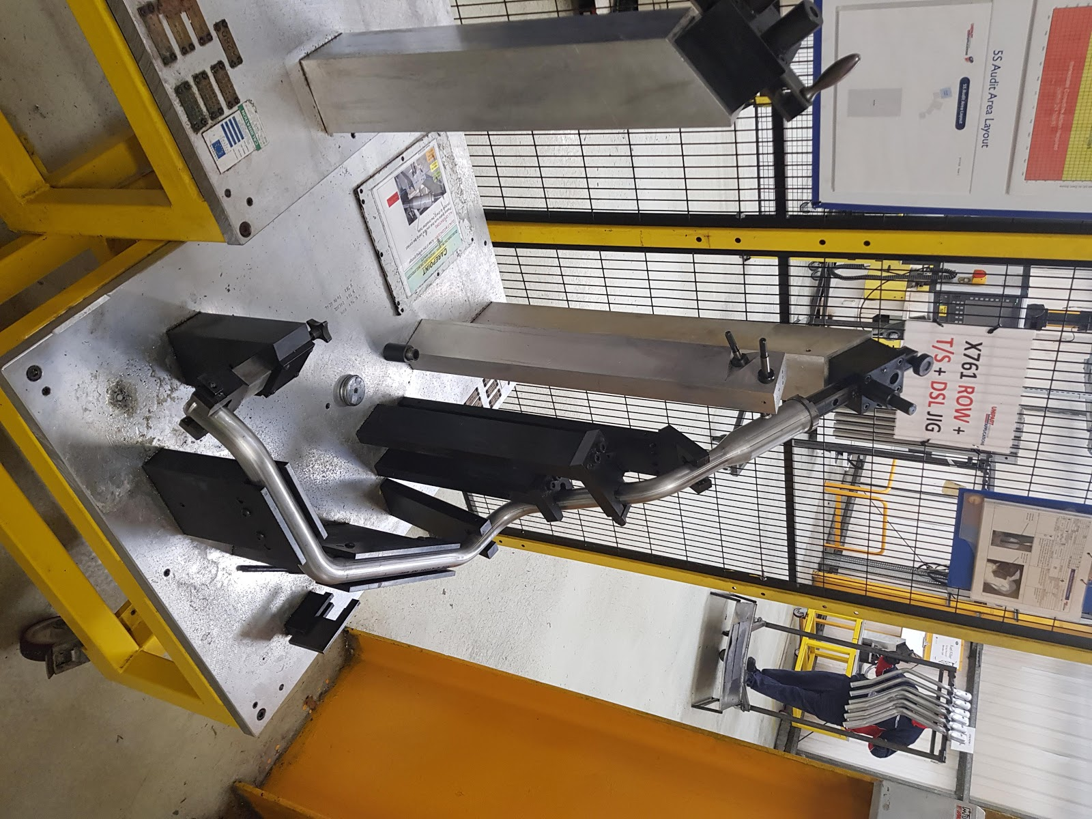

Figure 4.1-1 Current bending gauge

A copy of the calibration certificate for the jig was obtained (this can be viewed in Appendix 6). The calibration is measured using a FARO control arm. It should be noted that the jig is measured for calibration at the Standard Reference Temperature of 20°C土1°C. This is in accordance with ISO 1 which defines the reference temperature for ‘geometrical product specification and verification’ to be 20°C.

However, the area that the jig is kept in, on the factory floor, is not kept at the standard temperature and there are no measures in place to maintain even temperature and humidity. The factory is not insulated for temperature or vibration, hence changes in the outside environment or vibration from machine can directly influence the jig. Therefore, the calibration done on the jig is quickly undone, and any measurements taken cannot be verified to be precise. This may also pose an issue if Unipart aim to achieve UKAS accreditation for their metrology.

## **Endform Process (OP50)**

The endform process is the last process of manufacturing the fuel filler, it is the process after cutting the pipe and cleaning the end in the De Burr machine; the end part of the bent and cut pipe is then put in the cup form machine to form the endform of the fuel filler. The machine uses spinning of some round tools to create the endform shape needed. Each endform machine in the factory has its own dimensions on the shape of the endform. After finishing the process, the endform is then inspected visually and then is put in a gauge that checks the whole fuel filler’s bend angle, length and width, and the endform (see figure 4.2-1). The cup forming machine and the quality check gauge are suitable.

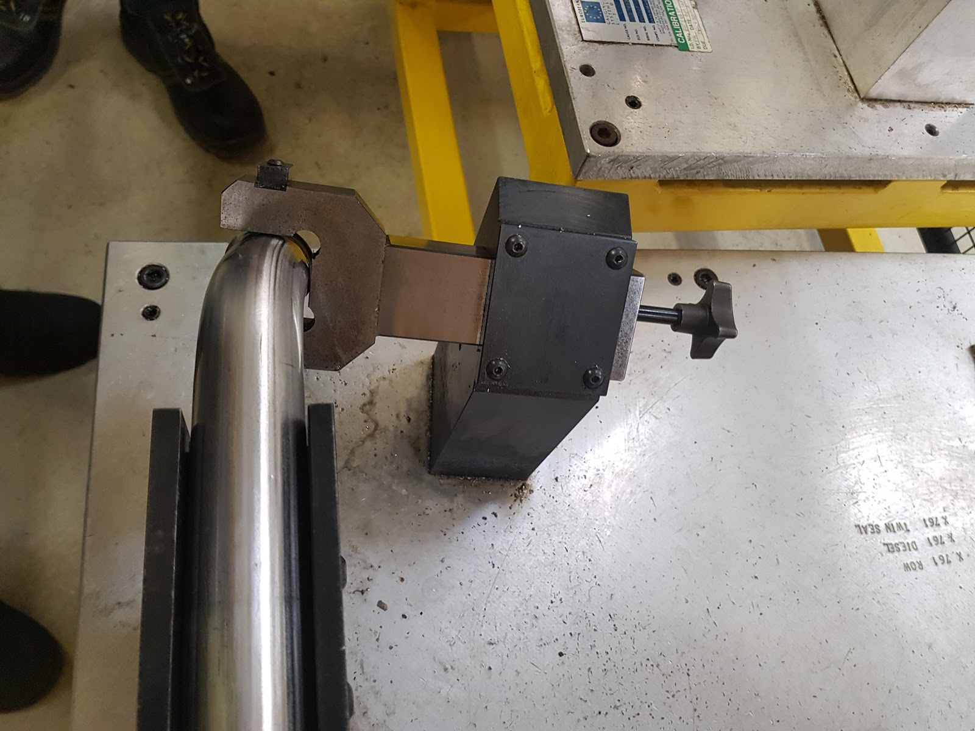

Figure 4.2-1 Endform test on jig

# **Future State Proposal**

## **Proposed FMEA**

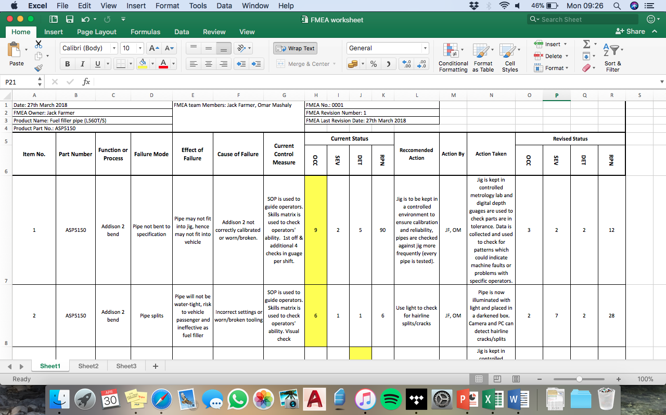

Figure 5.1-1 Sample of new FMEA

A new FMEA (see figure 5.1-1) was produced using existing failure modes identified by Unipart but with a new layout; and more importantly greater detail and consideration with future proposals for Control Measures and Recommended Actions.

The complete new FMEA can be found in appendix 7.

Unlike the existing FMEA, all relevant Severity, Occurrence and Detection numbers are clearly shown and the RPN calculations are completed for each failure mode. This means that the most serious sources of failure can be quickly identified and hence plans can be more quickly put in place. Quality ‘Guru’ Philip Crosby believed in the importance of identifying the 10 biggest quality problems, which gives Unipart and operators the aim to achieve zero waste by working to resolve the largest issues first. Identifying the largest problems can then be used as a basis for continuous improvement plans by Unipart.

Where SOD numbers were not present on the existing FMEA, new ones were created using scrap data that was collected and personal judgement on severity of issues. For example, the failure mode “Pipe not bent to specification” had to occurrence rating, though the collected scrap data found 38% were not bent to specification - hence the rating given was 8, which is defined as a failure rate of 1:3 by the key.

An additional failure mode was also added based on findings from data collection. This is for dimples on the pipe bends, as this was a significant issue on parts that were inspected (33% of fillers had a dimple at the same location). This was missing on the existing FMEA.

The existing Unipart FMEA relied heavily on using the Skills Matrix as a means of preventing failures. Whilst the Skills Matrix is important for gauging the ability of operators, the new FMEA focuses more heavily on collecting data from inspection of parts to test both part accuracy and the ability of operators.  This is heavily based on the ideas of Quality ‘Guru’ Philip Crosby who believed in the importance of collecting and using measurements as a means of testing quality.

By collecting data for 100% of parts using the jig which is retrofitted with digital gauges, this data can be automatically fed into a computer system which can be used by Manufacturing Engineers or management to spot patterns which could indicate either tooling becoming worn or certain operators having higher failure rates on certain operations. This data can then be used to determine if maintenance on machines is needed; or if certain operators need additional training.

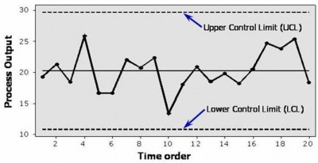

Figure 5.1-2 Example SPC chart

Data can be interpreted using SPC charts (see figure 5.1-2). Statistical Process Control Charts are used to visually identify how processes change over time. The X axis is in chronological order of each measurement, whilst the Y axis is used for measurements. Two horizontal line are also featured which are the upper and lower control limits. If a point lies outside of these limits this means the measurement is not within tolerance.

A separate SPC chart can be used for each dimensional measurement taken.

## **Proposed Control Plan**

The control plan that Unipart has had some errors as described previously in the report, and the checking is not as it should be as the first four fuel fillers are checked consecutively. So there is a proposed control plan that could be a better one than the original control plan existing right now in Unipart because it is a little more clear on how to detect the errors in the fuel filler after it is has been manufactured and during it is manufactured. The proposed new Control Plan can be viewed in appendix 8.

## **Alternative Methods for Quality Inspection**

### **Bending Process (OP10)**

Currently, the first filler produced is inspected, followed by an additional four pipes per shift. This is inadequate as theoretically four of the inspections could be left until the last four parts of the shift; and then the vast majority of the shift may in fact be out of tolerances but this would go unnoticed. This represents a huge waste of time potentially as the undetected scrap could not be sold and material would have been wasted. The parts would also need to be remanufactured once the source of the fault has been detected.

Hence it is proposed that 100% of parts are inspected using the jig at the end of the processes in the bending cell, though the jig will be adapted to provide meaningful numerical data. This would be in addition to double visual inspections - details on which processes have visual inspections can be found in the proposed FMEA (appendix 8).

However, this would cause an increase in the amount of time spent on inspection. It is estimated that each new jig test takes around 44 seconds, based on timing the current jig test. This investment of time should be worthwhile for Unipart, as it promises in theory a higher likelihood of scrap detection and machine fault detection - saving rework time in future.

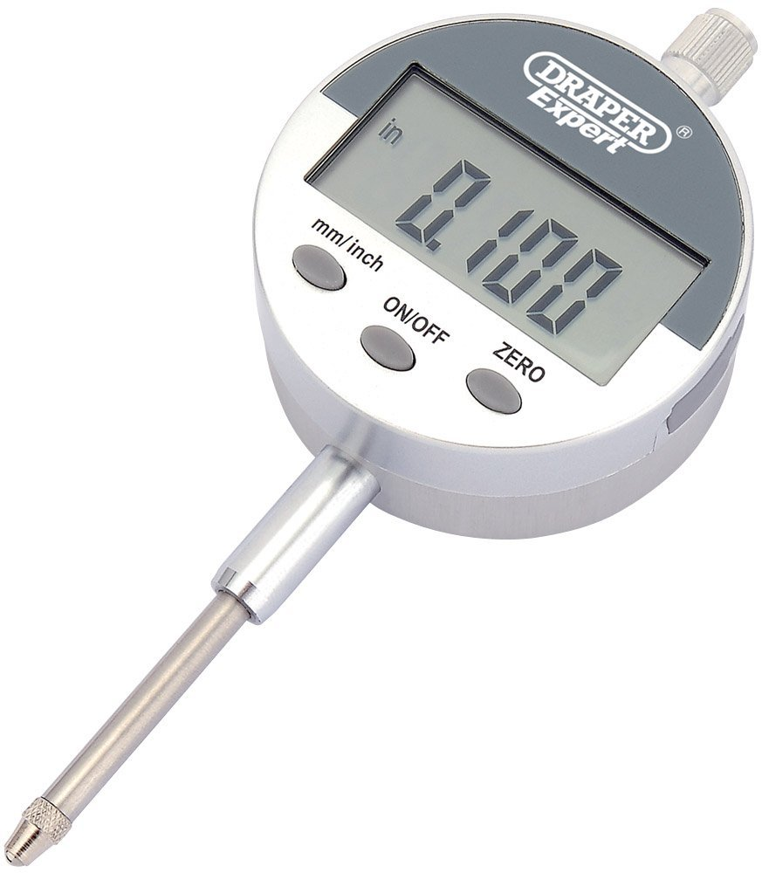

Figure 5.3.1-1 Digital Dial Test Indicator

It is proposed that the current jig is retrofitted with digital dial test indicators (DTIs). These would be fitted at 9 locations on the jig (see figure ??). The digital DTIs would be connected to a computer which would allow data to be automatically fed into a collection system. Data from each measurement would be input automatically in a database. This is faster than manual data collection, meaning the increased frequency of inspection would not have as much of a substantial impact on time.

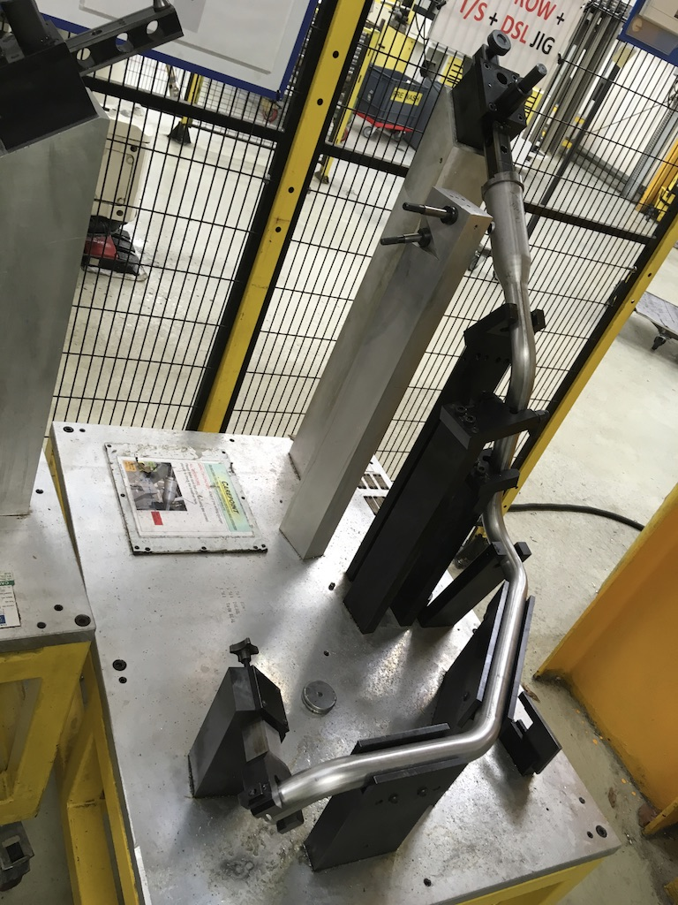

9

8

7

6

5

4

3

2

1

Figure 5.3.1-2 Digital DTI locations

As already mentioned, the data from the DTIs would then be used to generate SPC graphs which can be used for machine fault detection. If the SPC line begins to tend towards the control limits, this can be spotted before parts begin to be out of tolerance and steps can be taken to prevent faulty parts being made.

### **Endform Process (OP50)**

The endform quality check in Unipart is done by two ways, during the process the endform is checked visually by the operator, that of course is not accurate. After the process is finished the whole fuel filler is put in a gauge that checks the bending, the length, the thickness and the endform. But it is not accurate enough since the the gauge only checks the endform from the outside only.

In order to make the full check of the endform there is a proposal that should not be too expensive. The proposal is to get a small coordinate measuring machine (CMM), which would be small in size. The machine will basically be a small robot which has a small hand with a needle that will move around the endform from the inside and the outside to measure the accurate size of the hole. This will be accurate enough for the endform to be done correctly with no errors. This machine will cost around £8000, and the checking of this robot will be yearly just in case it has any program errors that needs to be fixed. Checking one endform will take a minute to move around and calculate the size. The CMM will be small enough to be put in front of the gauge and it will be small enough to only check the endform hole.

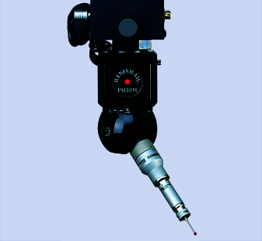

Figure 5.3.2-1 Example of a small CMM that can be used

The robot will be easy to use because it will be a single phase, and the machines used in unipart are a 3 phase machines. To use a single phase motor on a 3 phase power source, the single phase motor will just be connected between any of the 3 phase and the neutral or any of the 3 phases and another of the 3 phases. It also has to be balanced or else something wrong will happen to system, so there must be a circuit breaker just for safety (Quora 2012).

## **Piece Part Costing & Cost of Quality After Improvements**

After improving the process, all the costing for the endform will be the same except for the new ring proposed for the endform quality inspection, this ring will not be big in size, it will be small just to fit the opening of the endform, so it will not be very expensive, the cost to manufacture will be around 5 pounds so the only difference that the costing will have will be in the cost of quality.

The cost of quality for the endform will change only in the cost of detection; so the cost of detection including the cost of a CMM will change to $\frac{3X0.29}{31000}+\frac{104X0.29}{31000}+\frac{3995}{31000}+\frac{8000}{31000}=£0.39$. Including washing, the new cost of quality will be £0.45; so the new piece part cost will be 0.45 + 7.66 + 0.29 + 0.14 = £8.84. There will be no big difference in the cost if the new ring for measuring the quality of the endform is added.

The proposed DTIs will cost around £150 per part, and given 9 are needed that will cost £1350. Added to this will be the cost of a computer workstation which is used to automatically collect data from the DTIs, this is estimated to be around £400 based on the cost of a new computer, which does not have to be particularly powerful as it is used to collect data only. This gives a total new equipment cost of £1750.

Hence the cost of detection for the bending will change to $\frac{3X0.29}{31000}+\frac{104X0.29}{31000}+\frac{3995}{31000}+\frac{1750}{31000}=£0.19$. This brings the total per part (including cost of quality for endform) to £8.73.

It is worth mentioning the bill of materials does not change, as the design of the part has not been affected and hence it uses the same material and would be produced to the same specifications.

# **References**

British Library (2018) Philip Crosby: zero defects thinker [online] available from <https://www.bl.uk/people/philip-crosby> [10 April 2018]

British Library (2018) W Edwards Deming: Total Quality Management thinker [online] available from <https://www.bl.uk/people/w-edwards-deming> [10 April 2018]

Mitutoyo (2017) CRYSTA-APEX S544 [online] available from <<https://shop.mitutoyo.co.uk/web/mitutoyo/en_GB/mitutoyo/CRYSTA-APEX%20S900%20Series/CRYSTA-Apex%20S544/$catalogue/mitutoyoData/PR/191-243/index.xhtml>> [25 April 2018]

Quora (2012) Will a Single Phase Run on a Three Phase Power Source? [online] available from <<https://www.quora.com/Will-a-single-phase-electric-motor-run-on-a-three-phase-electrical-power-source>> [25 April 2018]

Coventry University (2017) 154MAM - Quality and Metrology [online] available from <<https://cumoodle.coventry.ac.uk/course/view.php?id=47454>> [26 April 2018]

Coventry University (2017) 155MAM - Manufacturing Electrical Science [online] available from <<https://cumoodle.coventry.ac.uk/course/view.php?id=48296>> [26 April 2018]

Coventry University (2017) 156MAM - Quality and Metrology Part-assembly Extension Project [online] available from <<https://cumoodle.coventry.ac.uk/course/view.php?id=52600>> [26 April 2018]

# **Appendix**

## **Appendix 1: Work Breakdown Structures**

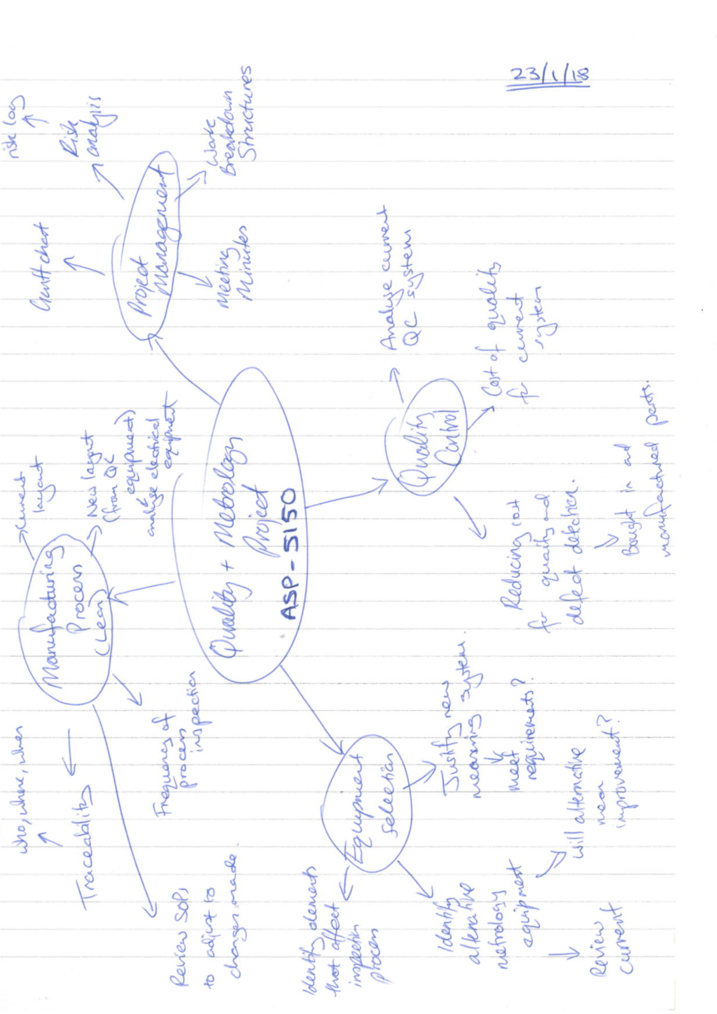

## Appendix 2: Data Collection Spreadsheet



## **Appendix 3: Current FMEA**

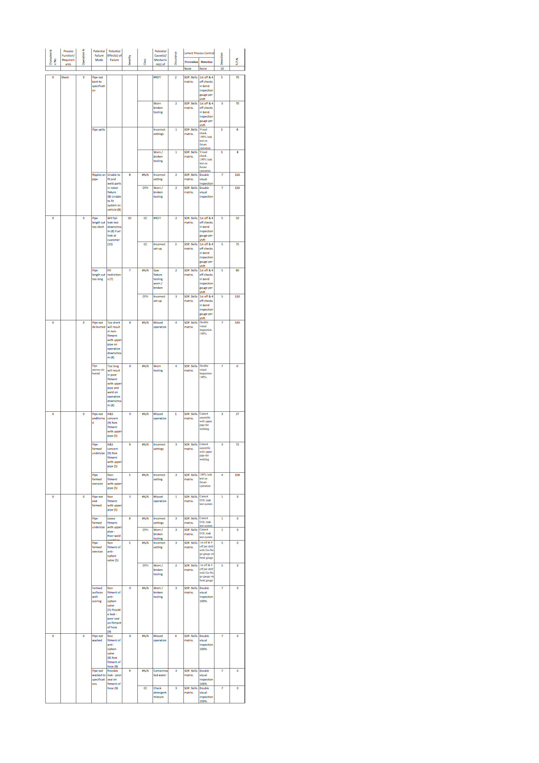



## **Appendix 4: Current Control Plan**

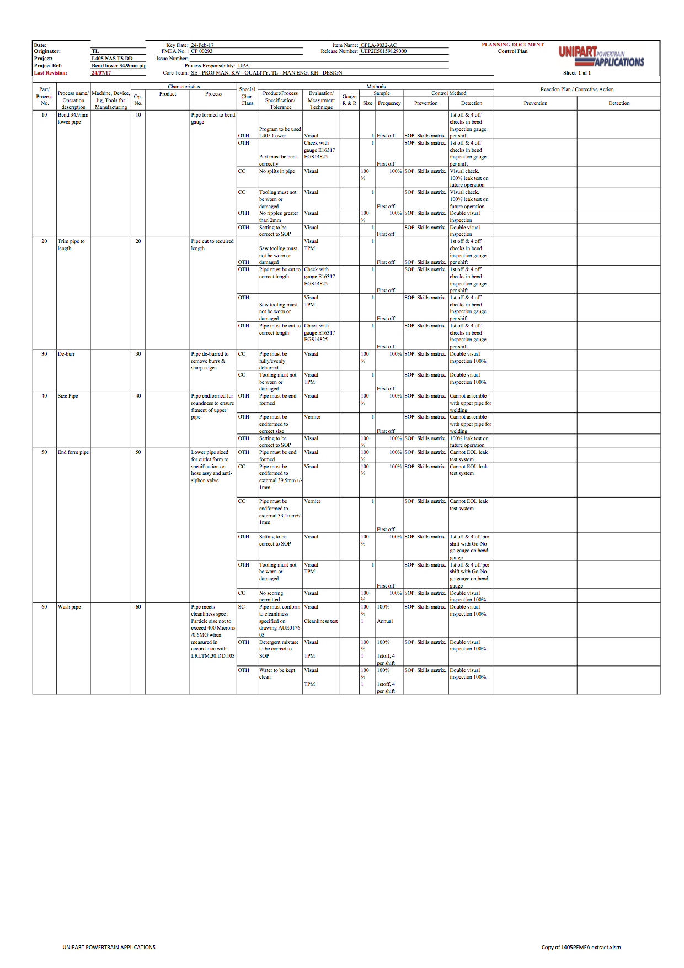

## **Appendix 5: Bill of Materials**

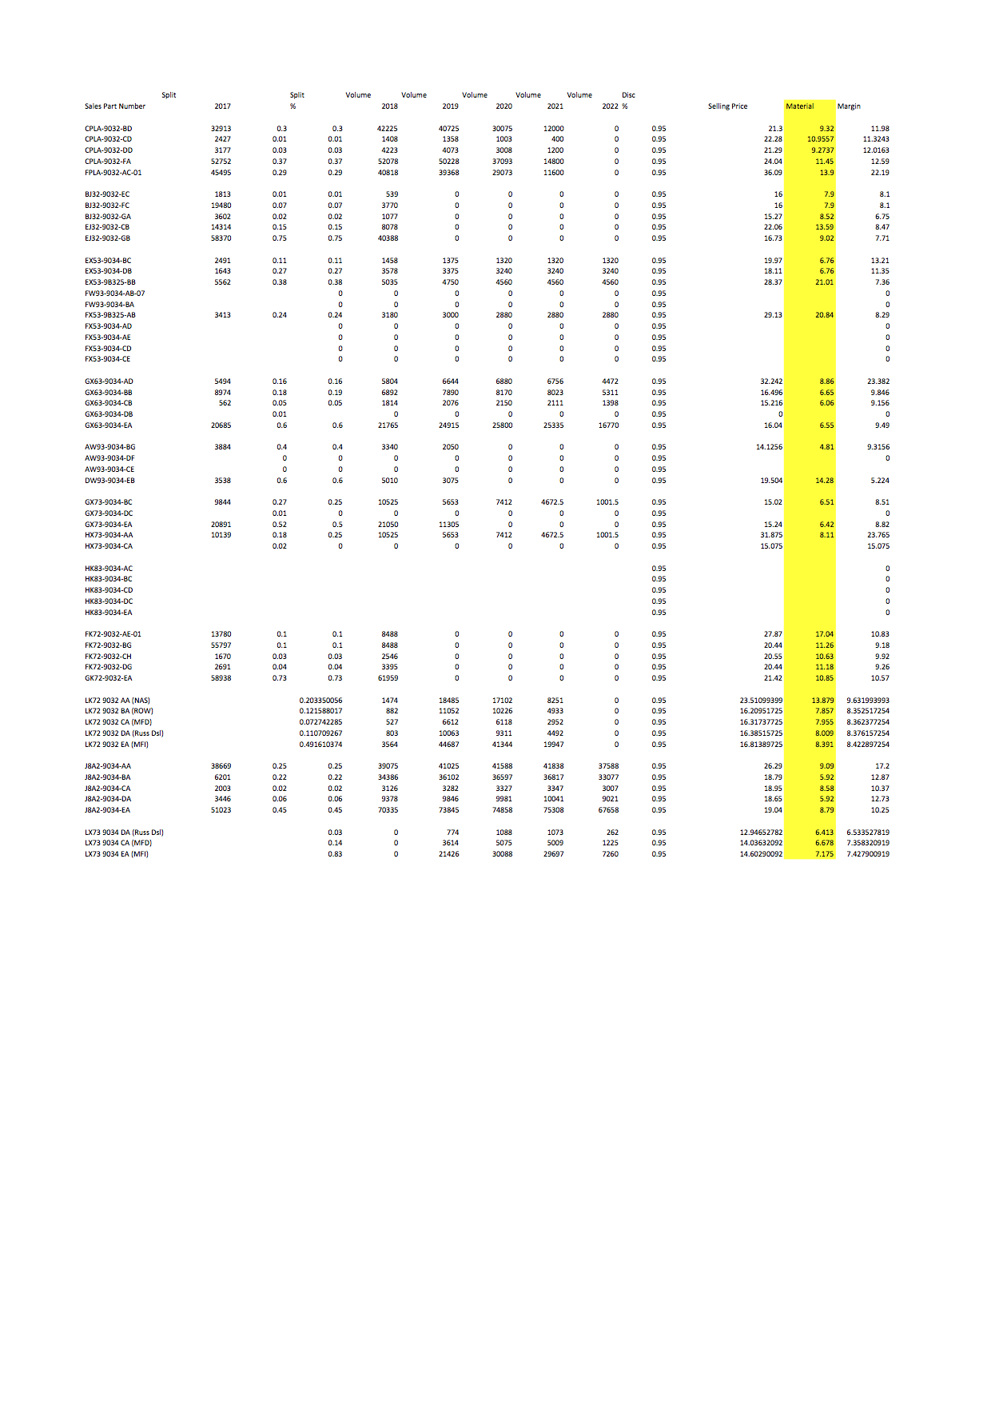

## **Appendix 6: Jig Calibration Documents**

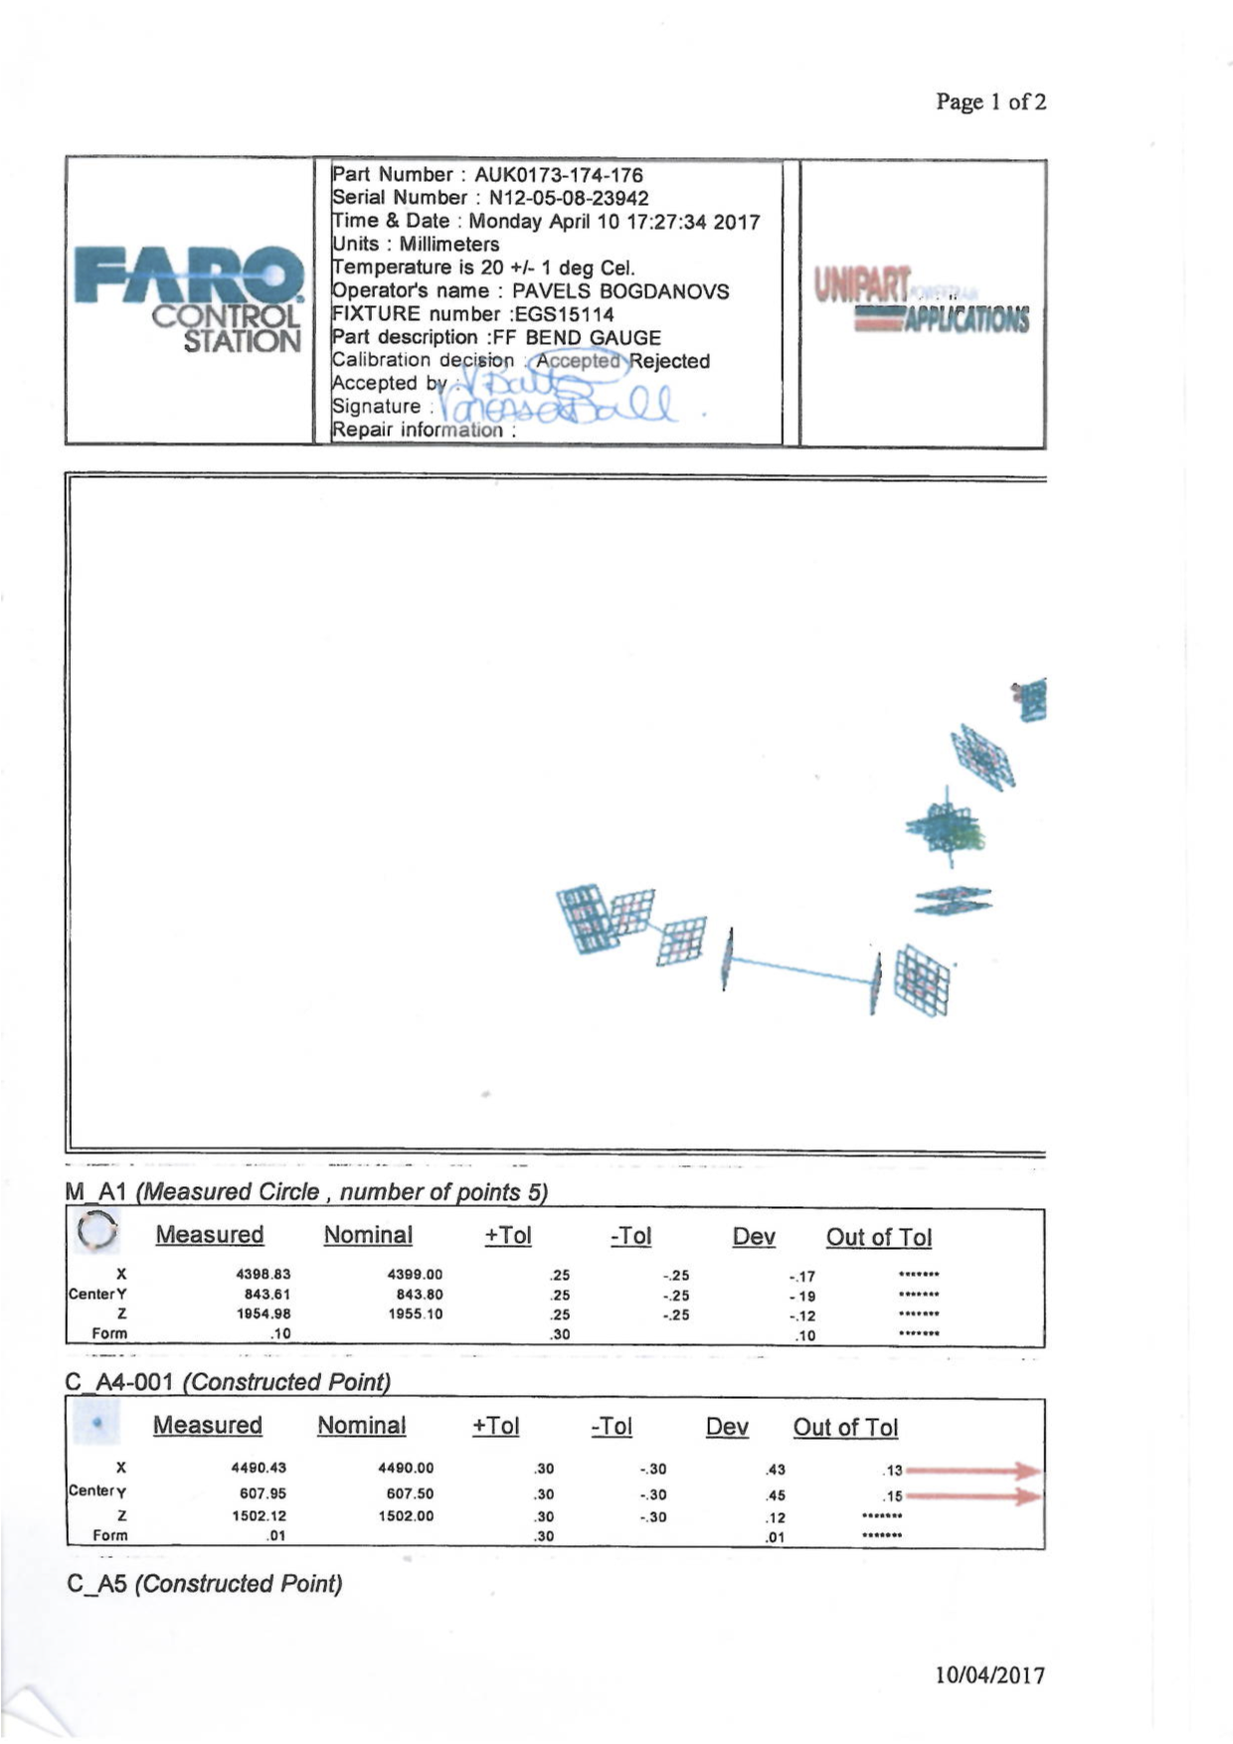

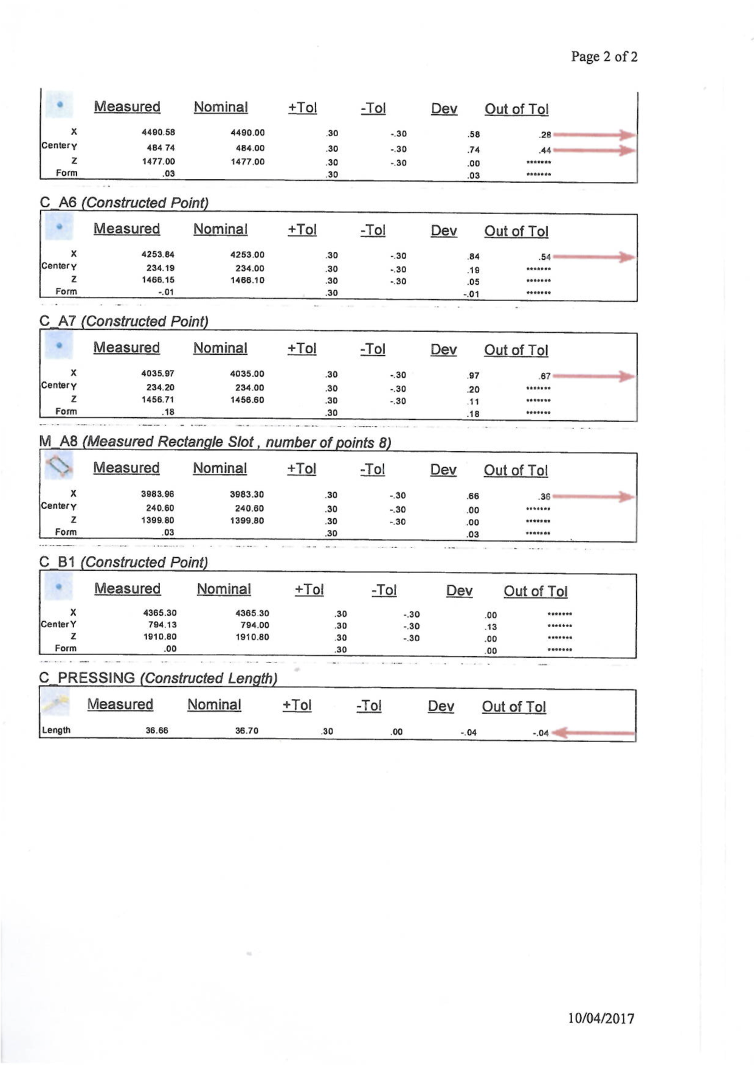

## **Appendix 7: Proposed FMEA**

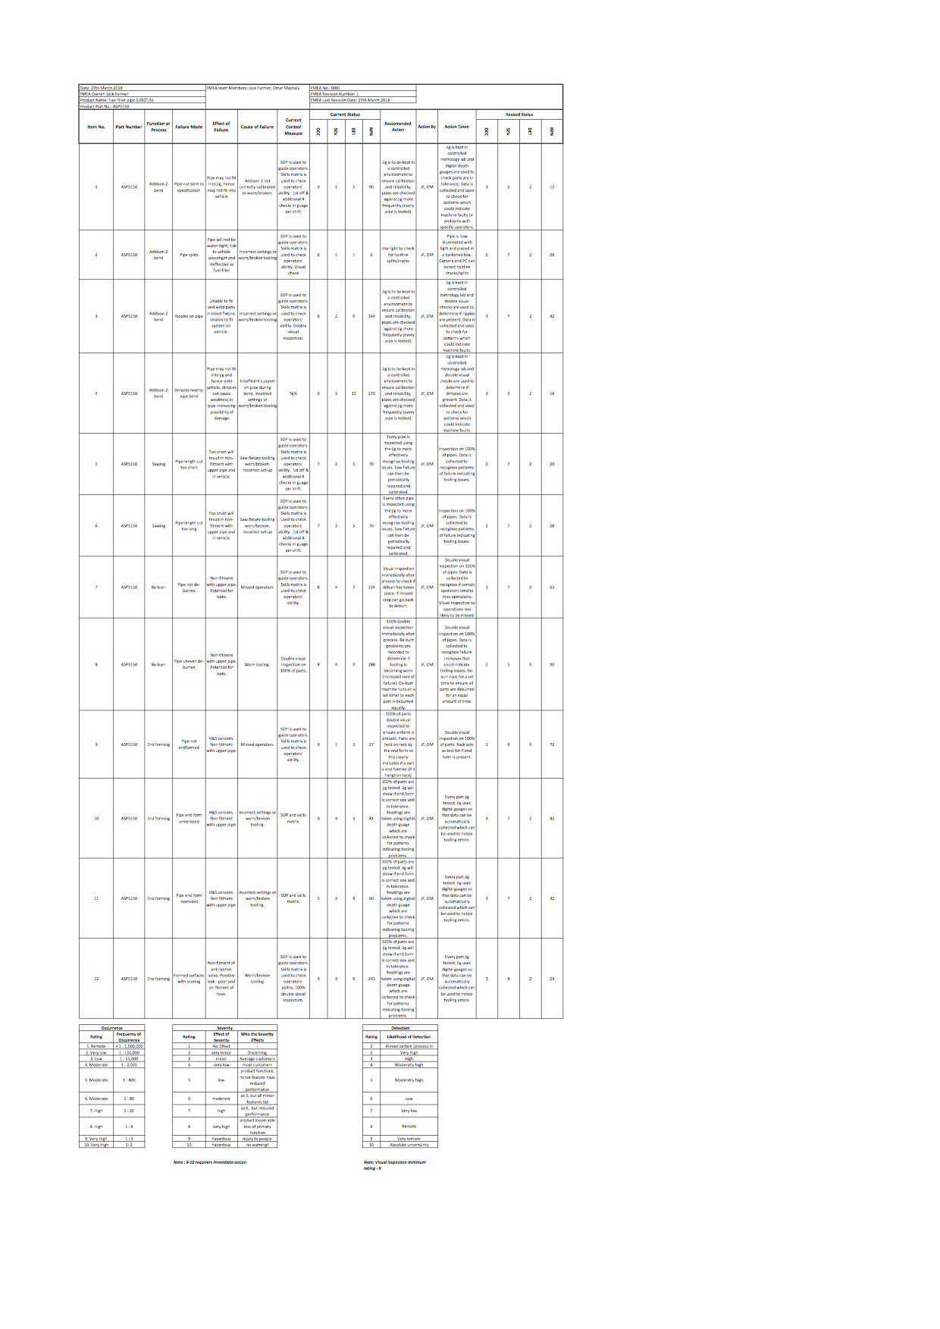



## **Appendix 8: Proposed Control Plan**









